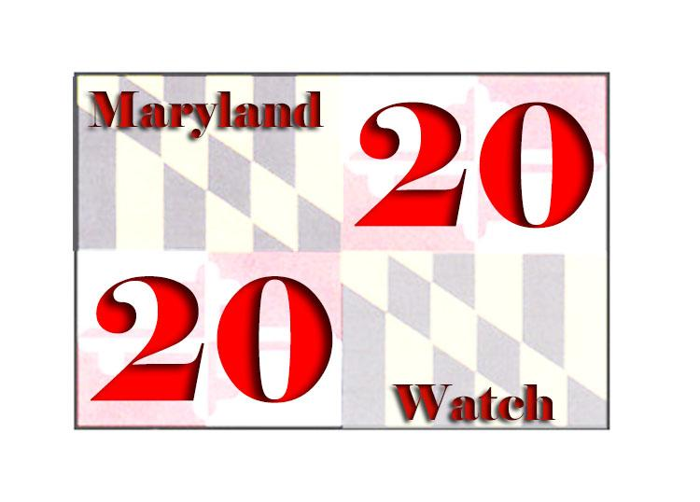
MARYLAND 20-20 WATCH
www.maryland20-20watch.org

September 19, 2016

The Honorable Larry Hogan, Governor
100 State Circle
Annapolis, MD 21401

Governor Hogan,

Maryland 20-20 Watch has extensively studied the 2016 Baltimore City Primary Election and has uncovered a number of election judge failures that appear to show an extremely high level of either targeted fraudulent behavior or gross incompetence in 21 polling places. The State Board of Elections even admitted that 71 precincts had discrepancies, but they failed to notify the public of the size and scope of those discrepancies. They failed to hold anyone accountable for those discrepancies; and they failed to make changes that would ensure these problems do not occur again.

Two of the primary missions of the Maryland State Board of Elections are to ensure uniformity of election practices and to promote fair and equitable elections. The Baltimore City Board of Elections’ mission is to ensure the proper and efficient conduct of elections. Election fraud in even a single precinct undermines all of these missions as well as undermines the legitimacy of Maryland elected officials and their governance.

Maryland Election Law Article § 2-102 gives the State Election Board the responsibility to ensure compliance with the law and supervise the conduct of elections in the State; direct, support, monitor, and evaluate the activities of each local board; and canvass and certify the results of elections as prescribed by law. The Maryland State Board of Elections has failed in these responsibilities in the Baltimore City 2016 Primary Election.

The Baltimore City Board of Elections, according to Maryland Election Law Article § 2-201, is subject to the direction and authority of the State Board and is accountable to the State Board for its actions in all matters regarding the implementation of the requirements of Maryland and federal law.

We believe there is ample cause to investigate the misconduct which occurred in the 2016 primary election and the roles played by the State Board of Elections Director Linda Lamone, Baltimore City Board of Elections Director Armstead Jones, and the head election judges for at least 21 polling places.

A member of your staff has indicated that as Governor you have no responsibility in correcting the negligent and/or fraudulent election practices, Article § 2-201 states otherwise. It affirms, “The Governor may remove a member for incompetence, misconduct, or other good cause, upon written charges stating the Governor’s grounds for dismissal and after affording the member notice and an ample opportunity to be heard.” Therefore, it is within your power and we expect you to do your duty and hold those election officials accountable.
Please send your response to me at P.O. Box 22 Spencerville, MD 20868 as soon as possible indicating what actions you plan on taking.

Sincerely

Lewis T. Porter, Leader

